The ROB(Righteous One Beckoning)’s Mind: A Short Story

Chapter 1

Dante is the manager of a Satanic Temple and spends his days in the living area attached to the temple. He has gone on wikipedia and learned all the infernal names. He decided to draw a pentagram in blood and invoke the infernal beings trying to send them out into the world to party. Dante seems pretty cool and is a lovable character, he wants life to be a party for everybody including the infernal.

Dante has containers of rams blood and he decides to draw a pentagram in the Satanic Temple. He chooses to draw the traditional pentagram with a star inside the circle and the top of the star at the top. He has studied magic and reasons the top of the star being on the top of the circle puts the spirit above the other elements of the craft. His goal is to put the infernal above the corporeal flesh of humanity. After drawing the pentagram, he laughs like the crypt keeper and fiendishly invokes all the infernal beings in alphabetical order.

With a fiendish voice and laughter Dante says, “Abaddon, Adramalech, Ahpuch, Ahriman, Amon, Apollyon, Asmodeus, Astaroth, Azazel, Baalberith, Balaam, Baphomet, Bast, Beelzebub, Behemoth, Beherit, Bilé, Chemosh, Cimeries, Coyote, Dagon, Damballa, Demogorgon, Diabolus, Dracula, Emma-O, Euronymous, Fenriz, Gorgo, Haborym, Hecate, Ishtar, Kali, Lilith, Loki, Mammon, Mania, Mantus, Marduk, Mastema, Melek Taus, Mephistopheles, Metztli, Mictian, Midgard, Milcom, Moloch, Mormo, Naamah, Nergal, Nihasa, Nija, O-Yama, Pan, Pluto, Proserpine, Pwcca, Rimmon, Sabazios, Sammael, Sammael, Samnu, Sedit, Sekhmet, Set, Shaitan, Shiva, Supay, T'an-mo, Tchort, Tezcatlipoca, Thamuz, Thoth, Tunrida, Typhon, Yaotzin, Yen-lo-Wang. And last but certainly not least, the Devil Himself! I command you all to go into the world and party with the vessels of men.”

Chapter 2

The president of the United States is celebrating a victorious attempt at becoming president. He called for a celebratory press conference and is at a podium speaking into the cameras and to the audience. He says, “This victory was somewhat expected. I am glad to finally be sure that I am now the most powerful man on the planet. I spoke with a pure hearted Christian man, his name is Robert, and he and I agree that it is better to feed the destitute in Africa then it is to feed child rapists, child sodomites, and murderers. I have such love and respect for Robert that I have made him my grand advisor. He is here today, Robert, come on out and speak your ideas to the press.”

Robert starts walking toward the podium, but the president continues to speak. “Robert is the most interesting guy I spoke to in my life, and I want you to give him the attention you would give me.” The president gets off the podium and Robert gets on the podium. Robert says “Thank you Mr. President. I’ve wanted the attention of the people during years of my life, and I am glad to finally be able to speak to them. Hello my fellow Americans. I wanted to be president, but my flesh is very weak. My ears hear a constant ringing caused by my brain ringing. It's a condition called tinnitus. I have weak nerves and a weak flesh. I want to explain my vision for global governing. It is a vision founded upon the instruction of Christ. I affirm to you that I have seen Christ in his proper form. He led and instructed me. In his proper form Christ is all the Love in the universe and concealed as matter in the air. Christ was in the air and said ‘This is my proper form.’”

Robert continues, “The Lord God with us, Ahavah the King sang to me and manifest Himself to me on his throne. Thus sang the Lord, the living God I Am, ‘Son of man, don’t you know you are my treasure? One day all my enemies will be deceased! At that time, men on Earth will prosper, and society will live in peace. Son of Man, go and tell the people, the marijuana, coca, and opiates are from me! I do not want my people to abuse them, but I want my people to party.’ The Lord God is a spirit, the spirit Love, and in Hebrew, the same name that spells Jehovah and Yahweh, spells Ahavah with a half silent first syllable. Ahavah is Love. God is Love. God on his throne is a plain humanoid spirit of hallowed light with a dark ribbon of dark light because He is the present of every present moment and ought to be romanced accordingly. When I looked down after seeing God on his throne, I saw a galaxy then I had a vision of galaxies lined up like cornrows four dimensionally. God is glorious and I am grateful to be a witness.”

Robert continues, “I want to talk about global governing. Christ came to save the world and instructed us to love our enemies, do good to those that hate us, and pray for those that persecute us. I believe we save the world from nuclear war by doing exactly what Christ told us to do. I want to explain what happens when we love our enemies. Israel and Palestine are fighting as enemies. If Israel built palestine reverse osmosis facilities for drinking water, and crop growing water, built recreation centers for happiness, and built high speed internet towers for happiness, Israel would be loving their enemies and the effect would be a destruction of the heart of the enemies, Palestinians wouldn’t hate Israel and would want Israel to enjoy their lives too. We need to outlaw warful avenues of expense and restore the Lord’s release. The Lord’s release restored means all brothers and neighbors have their debts canceled every seven years on the day of the Lord’s release. This would provide the most high thee ability to endlessly invest in peace.”

Robert continues “We should build agricultural, industrial, waste management, and housing facilities in all lands so the quality of life increases globally. We should build recreational centers and high speed internet towers for every human being to have access to a high quality life. We can use oil powered machinery to build man made rivers where we bring the ocean’s water inland for fish cultivation, hydroelectric generation, reverse osmosis desalination, and water sports. We can reverse desertification with water created by reverse osmosis desalination, earthworms, and shit. By treating the desert lands with water, earthworms and shit we can restore the land to a lush land for crops. We can do the thing and we should. Think about the things I am saying. While thousands starve to death those that ought to die are fed and protected. Child rapists, child sodomites and murderers ought to die, but the poor in Somalia ought not die. In the past those that ought to die didn’t and those that ought not die did.”
Robert continues, “I have with me a daughter of Love. Her name is Aviela, but I have given her the name Alibu. I have founded a kingdom upon her spirit and drafted my last will and testament in addition to a spoken word where I tried to take being king of the world seriously. I want you to think in terms of righteousness and wrong doing. It is righteous to feed and protect the destitute, it is wrong doing to feed and protect child rapists, child sodomites, and murderers. My last will and testament in addition to my spoken word and love making and multiplying music is found on my youtube page “Topic Robert Michael Becker'' I ordered, decreed, requested, and begged for an intelligent, charismatic, dextrous, choreographed and recorded pompous parade over the cremated remains of Every Chomo. Every child rapist and child sodomite is a Chomo and by virtue of mystic matrimony, every murderer is also Every Chomo. Lets pompously parade over the cremated remains of Every Chomo. Mr President, you promised me you would sign an executive order popping Every Chomo’s cherry, cremating them and then parading over their cremated remains. Please take the podium and explain the parade to our fellow American.”
Robert steps off the podium and the president gets back on the podium and speaks. “Thank you Robert, I did promise and I will deliver.” After the president says I will deliver a wave of darkness washes across the land and Ah Puch enters into the president. The president looks disoriented and confused then becomes very fierce looking in demeanor and speaks. “I am Ah Puch, and I have claimed this vessel to party with. I hold this truth to be self-evident, Every Chomo is equal to every saint, that all men are created equal to Every Chomo and men ought to feed and protect their fellows indiscriminately.”

Robert chants “Yode, Hey, Vahv, Hey” powerfully and cries out “My God please send down the Dragon’s spirit and grant me the power to destroy Ah Puch, I Am!” The spirit of a wizened sage dragon comes down upon Robert’s flesh and Robert transforms into a super human empowered by the Dragons spirit. After the transformation, Robert hisses at the president's vessel and Ah Puch comes out of the president and manifests in his original form like that from the popular MOBA game Smite. Robert then hisses again at Ah Puch manifest in his original form and Ah Puch falls over dead. Robert speaks “The Dragon can destroy all of creation with a single word in his origin tongue, in this form I can hiss destruction into anyone. I will rip out Ah Puch’s heart and seal his eternal fate. I have destroyed his life, he is dead, and I plan to finish him.
Robert bites a hole into the torso of Ah Puch and reaches into his chest through the hole and rips out his heart. He draws the star of David and the symbol of his craft with the heart of Ah Puch as the instrument and the blood of Ah Puch as the material. The symbols look like the following pictures minus the heart and the medal of honor pentagram.
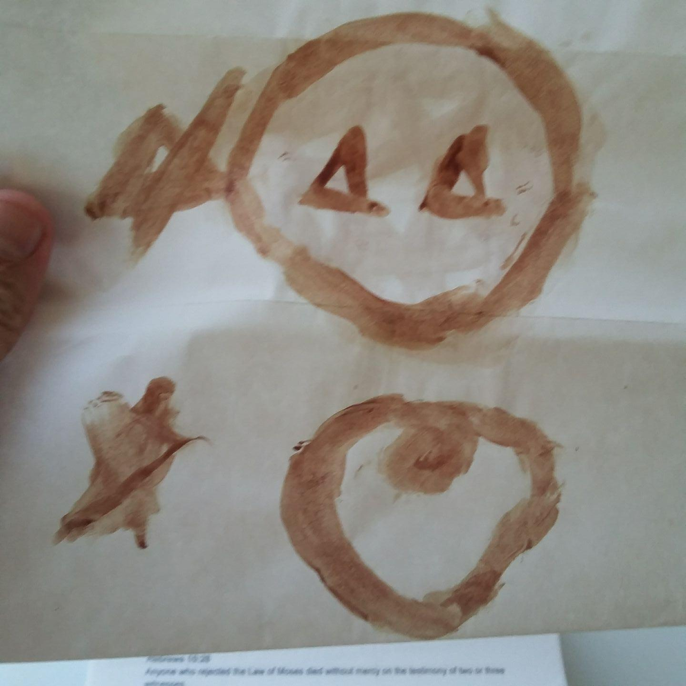
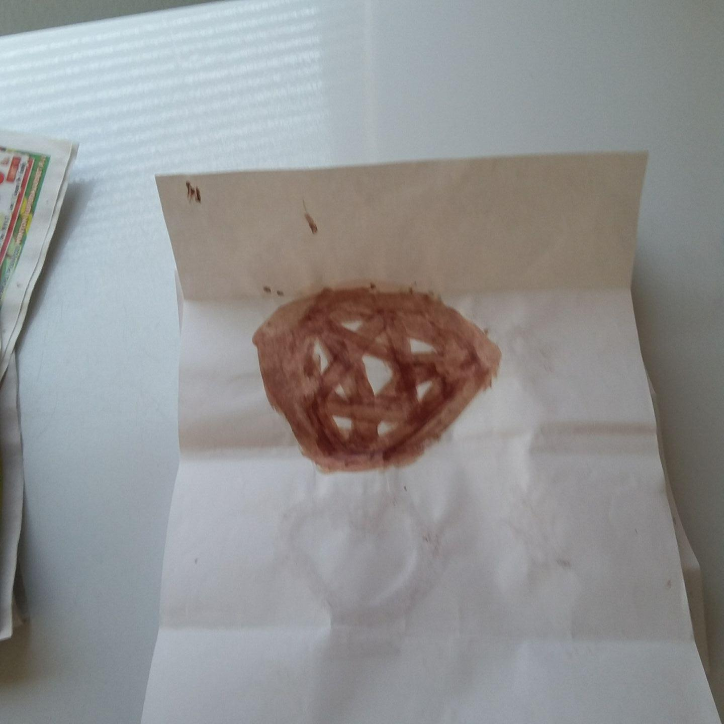

After drawing the symbols in Ah Puch’s blood, Robert chants “Yode Hey Vahv Hey” again and ends the chant with “I Am” and then “Craftality, flawless victory, perfect! I have waited from the beginning for this day. I am the Dragon, not the Devil, Lucifer is not me. Lucifer was my best friend, but now I count him as an enemy. I am thee ancient One, created, before time began, and I take as a disciple, Elijah Don Quickwit, thee, Grandson of Man. In absolute darkness, Lucifer, cannot stand, He forgets who he is and acts like a madman. I would go as far as to burn in Hell for all eternity, to see the will be done of the being that created me. I am the Dragon, you should believe me.” While all this is happening the audience of the press conference seem in awe and surprised. There are oos and awes, but there press seems at a loss of words.

The President stands up with a look of awe and gratitude on his face. He walks over to the podium and speaks to the American people. “I have been deeply humbled by this attack. Ah Puch caused me to say those things about Every Chomo. We men are not equal to Every Chomo, rather unlike Every Chomo, we men have dignity. I have already signed an executive order, ordering the pompous parade over the cremated remains of Every Chomo. Par with Mr. Becker’s request, I ordered their death via a spiky pool stick shoved into the asshole over and over again, again, and again, over and over again, until they bled enough blood to die, until it would be coroner certified, we popped their cherry. I ask all you members of the congress to vote to support the executive order. With the support of the senate, we can be parading a week from now. Mr. Becker, you are a god, and I am grateful you saved me from Ah Puch and I am ordering that you receive a Medal of Honor for valor. You have the form of a god, the Dragon is truly in you. You look like the disciple of Yoda Yang the Destroyer. I ask that you speak to the senate before they vote, because with the senate's approval Every Chomo is dead.”

Chapter 3

The senate is gathering to discuss the executive order and there is commotion about the grandiosity of what happened. The head senator calls for order and after everyone gets silent he speaks “Let's be honest, the only beings that would stand and fight to the death to defend Every Chomo are correctional officers, police and mercenaries, heroes, America’s finest, we dignified politicians hire them and they make a real living doing their job. I am Beelzebub and this is the vessel I chose to party with. Don’t act like I am the bad guy; Robert is the bad guy. He invoked perhaps evoked mystic matrimony and now Every Chomo has been mystically wed to Every Chomo’s bodyguards. Robert is here and I want him to fight me without using the hissing of the Dragon. What do you say Robert will you fight me without the tongue of the Dragon?”

Robert looks at the flesh of the senator and says “Come out of him manifest in your natural form.” Robert Hisses and Beelzebub comes out of the senator and is manifest in his original form. Robert Hisses again and Beelzebub dies. Robert then says “If you members of the senate don’t mind, I’m going to rip out his heart and seal his eternal fate!” The senators look surprised and in awe. One of the senators says “I find it barbaric, but if you must, seal his eternal fate with a craftality, let's party this is mortal combat!” Robert says “Thank you.” before biting a hole in Beelzebub’s chest and ripping out his heart. He then draws the same symbols he drew with Ah Puch’s heart and chants “Yode Hey Vahv Hey” before saying “I Am. Craftality, flawless victory, perfect”

The senator that had Beelzebub inside him says “Thank you Robert, I want you to do that to the Devil Himself. Let’s continue this meeting later after we clean up the mess Robert made. Call the janitors.” A man raises his voice in the audience of the senate “I am the director of the CIA, I am not the Devil Himself. I want to speak to every American about a prophecy I have.” The senator that had Beelzebub inside him says, “Come up here and address the nation then, I suppose with Robert ripping out the hearts of devil’s, we already have their attention” The CIA director walks to the speaker's chair and speaks into the mic. “If your a Arian or a wood I’m going to murder, you, mass murder you, properly, If your a Hells Angel or a Sureno I’m going to murdah, murdah, murdah, mass murdah, even botanists and Bikers are going to be murdered, murdered, mass murdered. East Side Las Vegas, I’m going to murder you, mass murder you, properly, murder, murdah, murder mass murdah, murdah, murdah, mass murdah. 1, 2, 3, the CIA is coming for your family, 4,5,6, after you die we will erase your birth certificates, 7,8,9, use your mind, CIA blacks ops is a perfect 10, there is no suspicion. We are going to murder your defense attorney Rob, If you're the Pope, we are going to murder you, mass murder you, properly, murdah, murdah, murdah mass murdah, murdah, murdah, mass murdah. Perfect 10 there will be certainty not suspicion. Fuck it, if your the sicilian mafia, we are going to murder you, mass murder you properly, murder murdah, murder mass murdah, murdah, murdah, murdah mass murdah. Murdah, murdah, mass murder. Remember our memorial rhyme, 1,2,3, the CIA is coming for your family. 4,5,6, after you die we will erase your birth certificates, 7,8,9, use your mind, CIA blacks ops is a perfect ten, Your punks better listen, you will have no peace, we will always have our agents stalking you on the streets. This is murdah, murdah, mass murdah. If you're one of our targets, die like a samurai and stick a sword through your gut, die honorably. I am not a false prophet, this is a prophecy, you will be murdered, murdered, mass murdered. Look at our picture prophecy, the Bible has images given to the minds of the prophets by God, we have drafted an image that explains us. Here it is, put our picture prophecy on every TV in America, because we will murder, murdah, mass murdah. Freemason Illuminati Rules the World! The following picture is printed on a paper he holds in his hand.

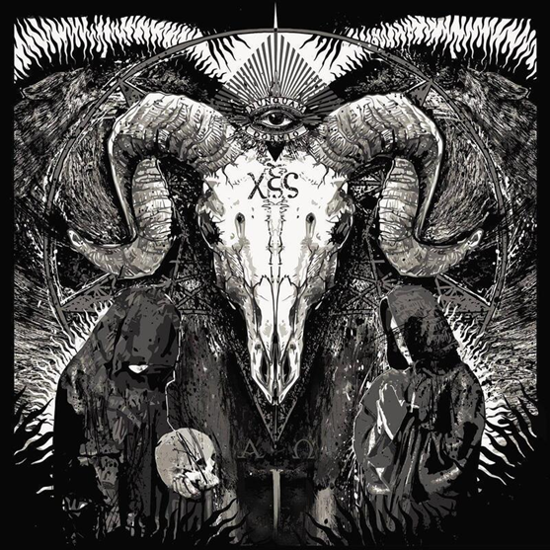
The senate seemed to be in awe but eventually there is a lot of commotion and disapproval about what the CIA director said. One of the senators raises her voice and says “Arrest him for conspiracy to commit murder and terrorist threats. A police officer walks up to him and says “You're under arrest for conspiracy to commit murder. The false prophet says, “I planned for this, I’ll be like Every Chomo, the correctional officers will be bodyguards that would stand and fight to the death to defend me. You can’t stop us, we are the Freemason Illuminati, we rule the world!” The officer says “You will be spending the rest of your life in protective custody in Prison, no pussy, no video games, no high speed internet. What do you think about that?” The false prophet replies “I’ll max my commissary and read hundreds of books, there is liberty for the captive!” the officer tells his coworker, “Take him to the station.”

The officer’s coworker takes the false prophet to the station to be processed and confined in jail. The CIA director AKA the false prophet is put into a holding cell with a man named Matthew Paula Wyson. Matthew says “Hi, I saw you on television, I bet you're the Devil Himself. I am the Mormon Beast. My name is Matthew Paula, holla, I’ll beat your ass for a dollar, I’m a shot calla, Matthew Paula…” He is interrupted by the CIA agent. “I do not want to hear you sing. I will be chillin in prison maxing my commissary and reading books while we wack the hosts of the Lord of Hosts.” Matthew Paula says “Don’t you know, Matthew Paula Wyson calculates to 666, I’m definitely an ally, even though I lived in East Side Las Vegas, I’m not a target right?” The CIA director replies “Of course not. Paula responds “The Devil stands only in the lie, we need to stand in the lie that we didn’t mass murder and that isn’t easy with cameras and other modern day realities.” My name is Ahriman, I have taken this beast as my party supply I am sure you're the Devil Himself, so work some magic and get us out of here.”

Robert AKA Rob, the ROB, is escorted into the police station. He says “I am sure the Devil Himself was inside him, take me to him” a officer replies “Okay, He is in that cell right there” Rob hisses at the CIA Director and the Devil Himself comes out of the body of the CIA director AKA the false prophet and Rob hisses again and the Devil dies. Rob looks at Matthew Paula and says “Go fuck yourself” Ahriman laughs and says “I am Ahriman and this is my vessel to party with, don’t ruin the party by hissing at me, instead…” Rob hisses at Ahriman and he comes out of Matthew Paula. Rob hisses again and Ahriman dies. Rob says “The hiss of the Dragon can destroy anything. This guy was a devil, there is not a need to take any chances. Now excuse me while I rip out their heart and seal their eternal fate.

Rob rips out the heart of Ahriman first and draws the same symbols as before He invokes “Yode Hey Vahv Hey” and finishes by saying “I Am, flawless victory, perfect!” He then rips out the Devil’s heart and draws the symbols. He starts chanting Yode Hey Vahv Hey and while He is chanting the Devil’s body grabs Robert’s foot and Robert finishes by saying I Am. Both the body of the Devil and Robert’s body is pulled into the symbols he drew and “Duel of the Ancients Intro” by Robert Michael Becker is played as Robert and the Devil begin to fight in the core of the Earth. Robert is in his godmode form caused by the Dragons spirit, and the Dragon himself speaks a dark utterance before Christ says Be. At the word of Be being said by Christ Robert and the Devil appear hovering over the water of the Atlantic Ocean about half way between America and Europe. The Dragon says to the Devil in a dark voice “You will hear me, How can this be?” and another wizened sage dragon spirit comes down on Robert’s flesh and he transforms into a giant with the appearance of a humanoid dragon of dark miasmic like light as flesh. The Devil says I Am, and transforms into an equally tall giant with a fire as flesh like Cousin It from Adam's Family only with fire instead of hair.

What Robert has become moves upon the fire of Cousin It and a very long series of hisses begins as Robert and the Devil struggle against each other. The fight is being watched by Christ from Heaven and one of the angels of Heaven is talking to Jeffrey A Becker, Robert’s brother. The angel says “This fight has been prepared for since the very beginning, all spirits of Good has a place in the vessel of Robert to help with the fight and all the spirits of Evil have a place with the Devil. The moment the Dragon hissed the sacred hiss while Robert was upon the Devil’s flesh the fight was decided. This struggle is recorded and will be explained to future generations. The actual fight is happening in spirit and cannot be observed by human means. We will be partying eternally and the reality of this fight will be explained. Just know this, the Dragon is the ancient One created before time began, and this victory over the Devil was prepared for.” Jeffrey says “Ok, so we won! WooHoo!”

Chapter 4

The senate has resumed its meeting about the pompous parade over the cremated remains of Every Chomo. The chief Senator is speaking and says “I am Azazel. This is my vessel for partying. Team Son of Man was betrayed by Judas with a world famous fang bang. We are not going to allow Team Every Chomo to lose, we are going to fang bang, lofty proper fang bang, the foes are acting very strange, hyper fang. If your a rat it's time to rat-allie-ally-ate, gather up the ninja turtles, you master splinters you, come out the sewers and rat ally ate, pull a rattata and evolve into raticate and irat-icate the enemies with a hyper fang to their jugular. We are rats, cockroaches and viruses, we will defeat Team Son of Man.

Robert magically appears in the room. He looks like an ever changing humanoid mystery of light and color. He is light purple, sky blue, and crimson. He is no longer a mere human and has become a mysterious god. He sings “I’m mighty, certainly mighty, if I am, then I am mighty, I am mighty it's a matter of fact, I just defeated the Devil in mortal combat!” He then hisses at Azazel and Azazel comes out of the man in his proper form. Rob hisses again, and Azazel dies. Robert begins to bite out his heart and senators speak while in awe. “Wow this keeps happening. Robert, is that you?” Robert has Azazel’s heart in his hand and is drawing the symbols when he replies “Yes I am Robert.” The senators look in awe but they don’t raise their voice to Robert. Robert finishes drawing the symbols with Azazel’s heart as the utensil and the blood of Azazel as the material. He chants “Yode Hey Vahv Hey” and finishes by saying I Am. The body of Azazel gets sucked into the crafts and Robert says “Craftality, flawless victory, Perfect.”

Robert talks to the senate about the parade. I am Robert AKA Son of Man Going. You have seen me going and know what I can do, do not oppose the intelligent, charismatic, dextrous, choreographed and recorded pompous parade over the cremated remains of Every Chomo or face the rather of everlasting contempt. If you were every chomo’s bodyguards, during all eternity you were every chomo’s bodyguards. All those in favor of the parade raise your hand and say I. Every senator raises their hand and says I. Robert says, thee I’s have it. We will parade ASAP. Where is the president? The president says “Here I am.” and Robert says “let's get ready to pompously parade over the cremated remains of Every Chomo.”

Chapter 5

A few weeks have past and the ROB is with the president at the white house. They are sitting in chairs and the president says “I have a special surprise for you ROB. The dominatrices of all Europe has joined themselves with the dominatrices of Germany and they are going to be in tight latex leather marching like show girls heiling Becker while we parade over the cremated remains of Every Chomo. We have executed Every Chomo and cremated them. The execution was a cherry poppin and they died of blood loss. The executioners furiously shoved a spiky stick into their assholes until they bled enough blood to die, the coroner did certify, we popped their cherries. Let every would be chomo tremble in fear and be turned away from raping or sodomizing one of our children!” Rob replies “Great. I am getting all my hearts desires.” The President says “Lets go outside, the parade starts at the whitehouse and the soldiers are ready.

They walk outside the white house and join the soldiers. The parade begins with a blowing of the trumpet. The soldiers do dances and flips with an awe inspiring formation and execution of dance. The dominatrices heil Becker and march like showgirls. The thing is amazing and recorded for all future generations. The ROB experiences a rapture, a spiritual ecstasy as he marches over the cremated remains of Every Chomo. The ROB does an original dance move to begin with and dances with his hands after. He does the big bang, a dance with the hands pointing in 8 cardinal directions then forming a heart and then clapping the hands to signify the big bang. Everybody seems to have a good time. After the parade the president gives a speech explaining that all future generations will know that men pompously paraded over the cremated remains of Every Chomo, men didn’t stand and fight to the death to defend every chomo.

Robert joins the president during the speech and talks about the work we need to do to establish a party for all humanity. Using oil to power machinery to build man made rivers to reverse desertification thereby making the desert a lush place to live. The world agrees to do the work and as weeks pass the progress begins to be noticeable. Africans plant nut trees so close together by the time they are grown the trees will be counted as a forest. They make plans to have the forests be a tourist attraction with audio equipment. Macaws will be brought to dwell in the forests. After a few years the world is in the spirit of peacetime work and by listening to Robert explain the will of Love for all humanity, the nations agree to beat their swords into plowshares and live lives of peace.

Everybody on Earth bows down to Love and invokes the everlasting name I Am at least twice daily, and the lives of all humanity is centered around being the reality Love desires that we be. Children are taught to submit to Love and in submission be, Love manifest on Earth a reality. To multiply Love and represent Love supremacy. That life on Earth can actually be, perfect for all humanity, we need only obey Christ’s instruction whole heartedly, to love the enemies and do good to those that hate thee. Robert believes he received all his heart's desires and life is going perfectly.

Chapter 6

Robert wakes up in a straight jacket in a psychiatric hospital. He is surprised and there is a doctor seated on a chair in the room. The doctor says “If you stop fighting us we will take you out of the straight jacket.” Rob says “Where am I?” The doctor says “You are at the state hospital and have been suffering from acute psychosis.” Rob replies “Where is the president. Why am I here?” The doctor replies “The president is at the white house, where else would he be? You are here because you are severely mentally ill. You think you're a god that has killed the flesh, took the soul, ripped out the heart and sealed the eternal fate of the Devil and his kin.” The ROB replies “So it all happened in my mind, we didn’t pompously parade over the cremated remains of Every Chomo?” The doctor replies “I assume you mean pedophiles, no, every pedophile is safe in prison where they should be.”

The ROB says “So there isn’t world peace and prosperity either? We didn’t build the rivers or plant the trees? We didn’t reverse desertification?” The Doctor replies “Nope. the desert remains a desert and there is no world peace, there are actually wars being fought today in Israel and other places. There are no man made rivers, it's all delusion in your mind. Life is tragic, not perfect Mr. Becker” The ROB says “But I achieved all my heart's desires, and then I woke up in the mental hospital, it was all in my mind. I hate this world, let me talk to the president, we can still parade and make world peace.” The doctor says “The president doesn’t have time for you. You have delusions of grandeur, you cannot make world peace, there will always be war. The ROB “So men continue to feed and protect Every Chomo, but do not feed and protect the homeless and destitute?” The Doctor, “Yep, men are men, we are all sinners.”

The ROB says “Oh I hate this world, what a dream, I obtained all my heart's desires, I killed the Devil, paraded over the cremated remains of Every Chomo and created world peace. I want to go back, send me back.” The Doctor, “Its all in your mind, life is tragic not perfect, will you take your medication?” Rob is dismayed and realizes that all the things that happened were only in his mind. He refuses to take medication and is forcibly medicated. He eventually gets released from the hospital to a group home where he stops drinking fluids until he dies of dehydration. He believes life on Earth can be perfect, but isn’t and because proud sinners have their will done instead of the will of Love, we all suffer. Rob has plans to party with Love and the kin of Love eternally, but he has and will probably have a very real hatred for those in power that sin and offend in sin rather than doing the perfect will of Love. Love is real, eternity is real, and Robert plans to be a real part of eternity.

